CONTENT

INTRODUCTION PG. 3
1. THREE MAIN TRIGGERS PG. 4
2. MYTHS AND TIPS FOR EXERCISING SOBRIETY PG. 5
3. STRENGTH TRAINING: NEW KID ON THE BLOCK PG. 9
4. STRESS PG. 11
5. THE 3 LITTLE PIGS PG. 14
6. CONCLUSION PG. 15
ABOUT THE AUTHOR PG. 16
ABOUT DR. FITNESS USA PG. 17

- INTRODUCTION
If you are in charge of a treatment center dealing with high profile clients, celebrities and executives, or are yourself experiencing frequent relapses, then I would like to show you how increasing your strength from 20% to 50% in 20 minutes can improve your odds for long term sobriety by reducing three of the most common triggers that cause relapses, Stress, Emotional or Physical Pain and Relationships, in a simple, safe and sustainable way.

We all know the importance of exercise for general well being, and to prevent illnesses or aging prematurely. It has been scientifically proven that physical fitness, and more specifically resistance training, results in lower mortality rate, helps in the prevention of diseases such as cancer, osteoporosis, obesity, cardiovascular diseases, endometriosis and even is helpful in fighting depression and in stabilizing mood behavior.^{1.} Although people tend to think of exercise as just good for the body, it also benefits the brain. Studies suggest that regular exercise can decrease drug use² and produce the formation of new neurons in the brain.³

Nonetheless, nowhere in the official guidelines for recovery, is there a mention of the importance exercise, or strength training more specifically, may play in the field of recovery!

Regardless, recovery centers and individuals are naturally beginning to incorporate certain types of exercises such as yoga, walking, or even personal training in their recovery action plan.

Critical factors are overlooked when selecting an exercise modality to support the recovery process and assist in controlling the negative effects of the three most common triggers that lead to relapse.

2. THREE MOST COMMON TRIGGERS TO RELAPSE

- STRESS
Stress response hormones such as adrenaline and cortisol are released via the sympathetic nervous system. The heart rate increases, causing blood vessels to constrict, blood pressure to increase and mental acuity to go up as a result of the fight and flight response. Exercise stimulates the release of endorphins and neurotransmitters that help relive the stress response, and cardio vascular responses modulate stress. Exercise is a form of meditation that takes the mind off stress factors.⁴

20% TO 50% strength increase in 20 minutes establishes a brain-muscle connection that will give you an immediate feel-good sensation while assisting you towards permanent lifestyle changes
- You will feel alert and alive
- Experience almost instant quieting of the mind
- Gain unshakable self-confidence
Being stronger and feeling better makes life easier. You will save time, money and energy,

- PAIN
Whether it is physical or emotional, pain is one of the main triggers to relapse. Addictions alter the brain chemistry affecting thought process, decision-making, and the ability to cope with pain. Relapse happens in stages, beginning with frustration and internal pain, uncontrollable negative emotions such as anger, resentment, anxiety, fear, etc…. leading to an inability to think things through and make healthy decisions under pressure. One of the reasons relapses are so common is that temptations seem to emerge out of nowhere. In fact, many invisible pressures, psychological and circumstantial, may build gradually, and then suddenly combine to push the person over the edge. Research shows that exercise leads to the release of certain neurotransmitters in the brain that alleviate pain, both physical and mental! ⁵

The foundational principals of the Body Design Formula strength training system, which are based on proper ergonomics and postural alignment, enable the client to increase strength from 20% to 50% in 20 minutes. This process has a profound effect on the nervous system (as explained in the NERVOUS SYSTEM chapter) and produce almost instant quieting of the mind and pain relief.
The principles applied help to
- Avoid hurting yourself and reduce destructive behavior
- Release physical and emotional tension
- Gain emotional sobriety
The massive amount of endorphins produced and released by the workouts will help fight against depression while allowing you to make better decisions under stress, decreasing chances of relapse.

- BEING UNCOMFORTABLE IN ONE’S BODY
Addictions are rooted in a profound dislike of being grounded in the body. In recovery, much emphasis is placed on the social / psychological / emotional causes of the disease. When it is all said and done, the fact remains that one has to live in her/his body and that incorporating specific tools to become stronger and more balanced physically will inevitably have a positive effect in the recovery process, quality of life and long-term sobriety achievement.
By sculpting muscles with the Body Design Formula you will acquire
- Amazing athletic strength and stamina, fast
- Irresistible charisma and poise
- A body you will fall in love with

3. MYTHS AND TIPS FOR EXERCISING YOUR RECOVERY

As mentioned above, alcohol and drug abuse changes brain chemistry overtime, which affects judgment, memory, emotional states and perception and that these side effects last long after the individual has stopped using the above substances.

Although people tend to think of exercise as just good for the body, it also benefits the brain, as it produces the creation of new neurons. Exercise increases oxygen in the brain by opening new pathways internally, and promotes the formation of blood vessels in the brain, builds connections between cells, enhances repair of neural tissue, and generates new neurons in memory formation areas! ⁶

This is exciting news as it has become scientifically proven that exercise isn’t just good for occupational therapy in the field of recovery, but it actually has the potential to repair brain cell damage and assist in mood elevation and stabilization by increasing the production of mood-boosting neurochemicals such as dopamine and endorphins. Other studies indicate that it even has the added benefit of potentially tempering impulsive / compulsive behaviors, as it also increases production of serotonin.⁷ This means fewer relapses resulting in an increased recovery success rate, which is at the alarming low rate of 3 to 5% to date.

Does every exercise produce the same results? No! The general belief is that cardio promotes weight loss, yoga creates long, lean sculpted bodies or that a local personal trainer will give you the discipline and tools to achieve the body of your dreams. While these statements may hold some truth to them, the notion that all exercise provides maximum opportunity for brain health and recovery is a myth. Here are some of the most popular myths that keep people stuck in dead ends, and more often than not even injured.

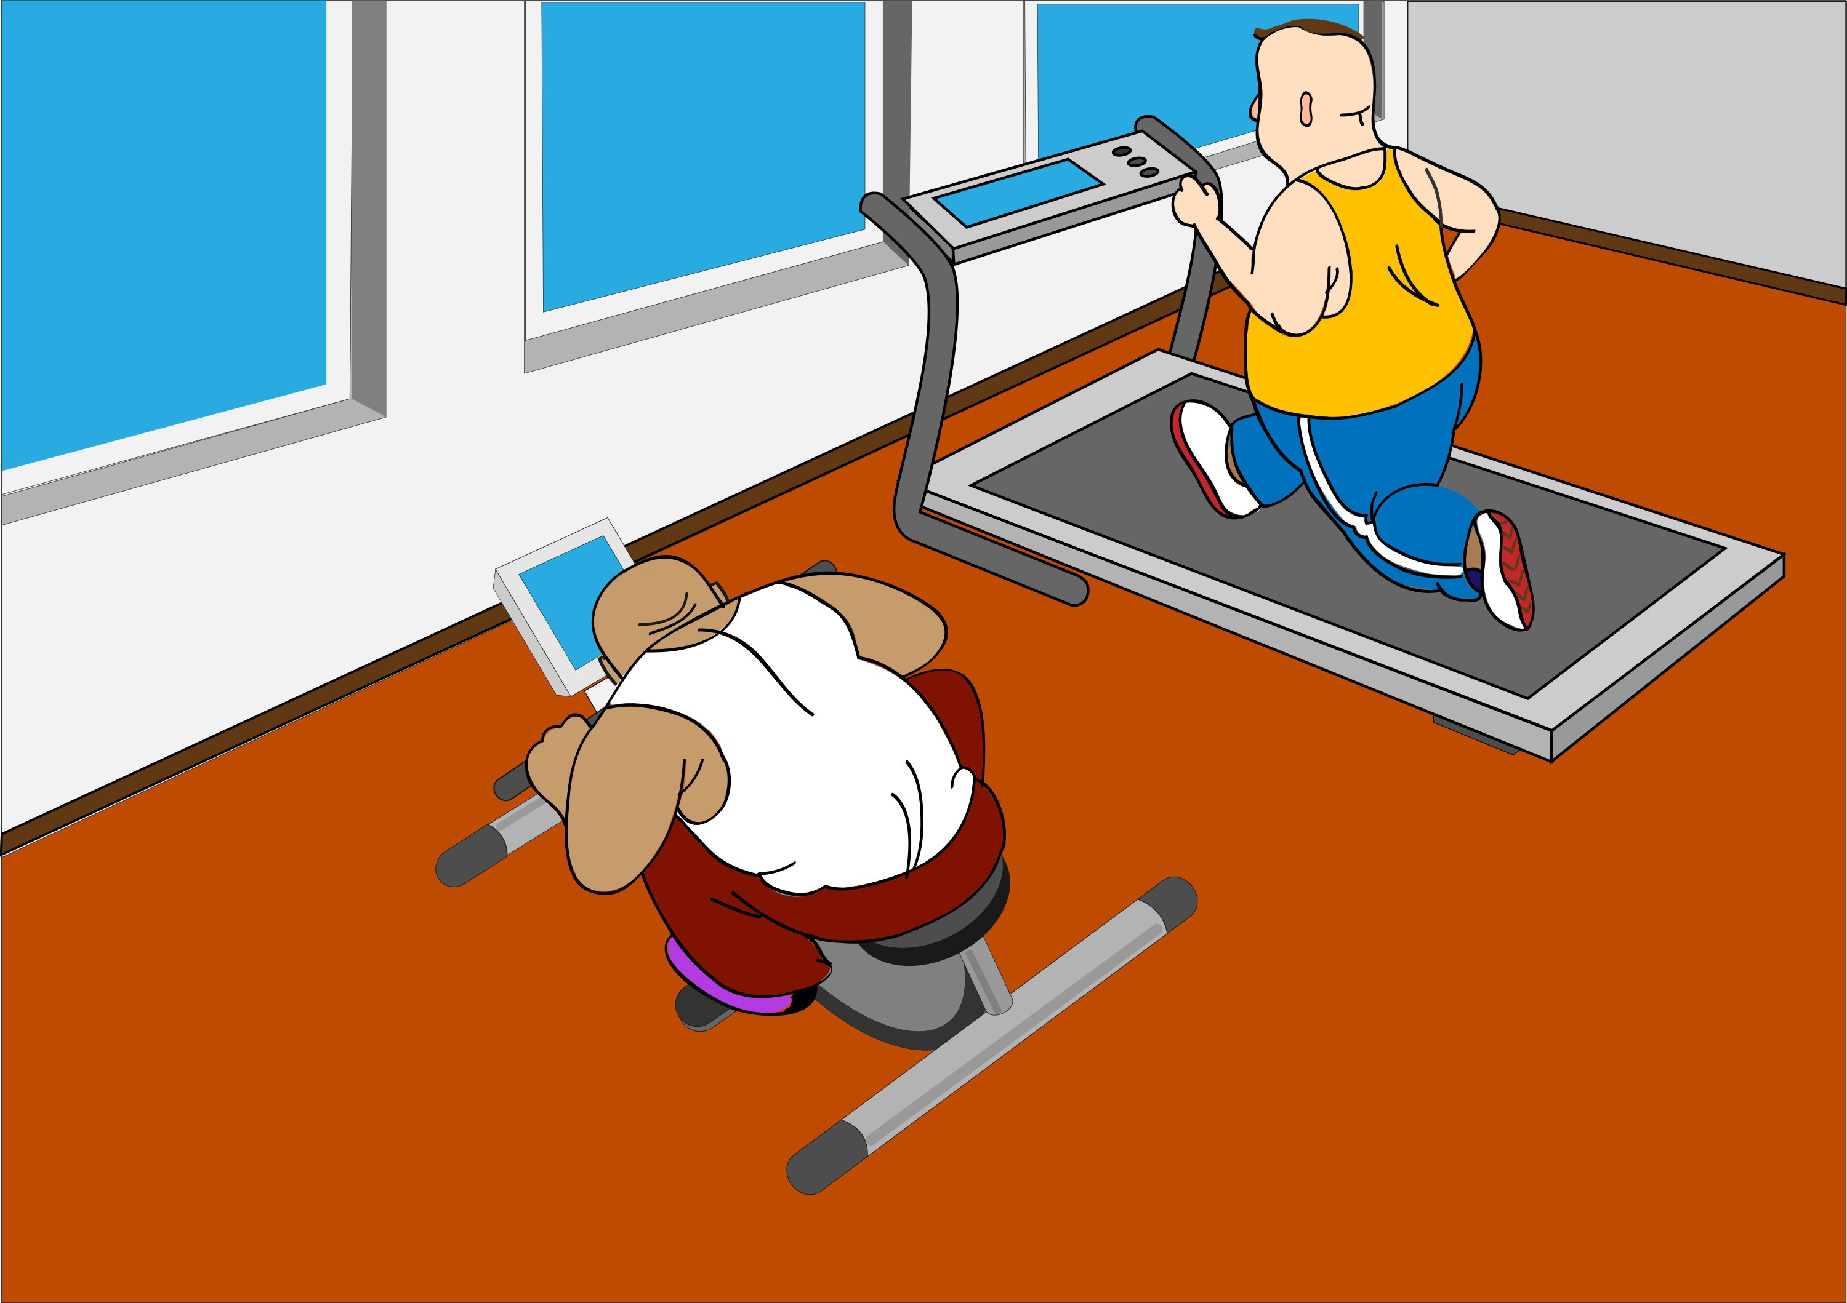
1 Losing weight with cardio: Aerobic activities facilitate burning calories for only the duration of the chosen activity, it also produces a large amount of cortisol in the body (stress hormone) that suppresses the immune system. This can produce weight gain and inflammation. It is hard on the joints. Cardio does release endorphins, so you will have a feel-good sensation, but the negative side effects are numerous and great.

Alternative Tips: A better and more efficient way to go is to change the composition of your body by replacing fat cells into muscle cells through Strength Training. This will further boost your metabolism by enabling you to burn calories up to 72 hours after your training. Strength Training is just as beneficial for heart health as cardio and is known to release massive amounts of mood boosting neurochemicals faster.

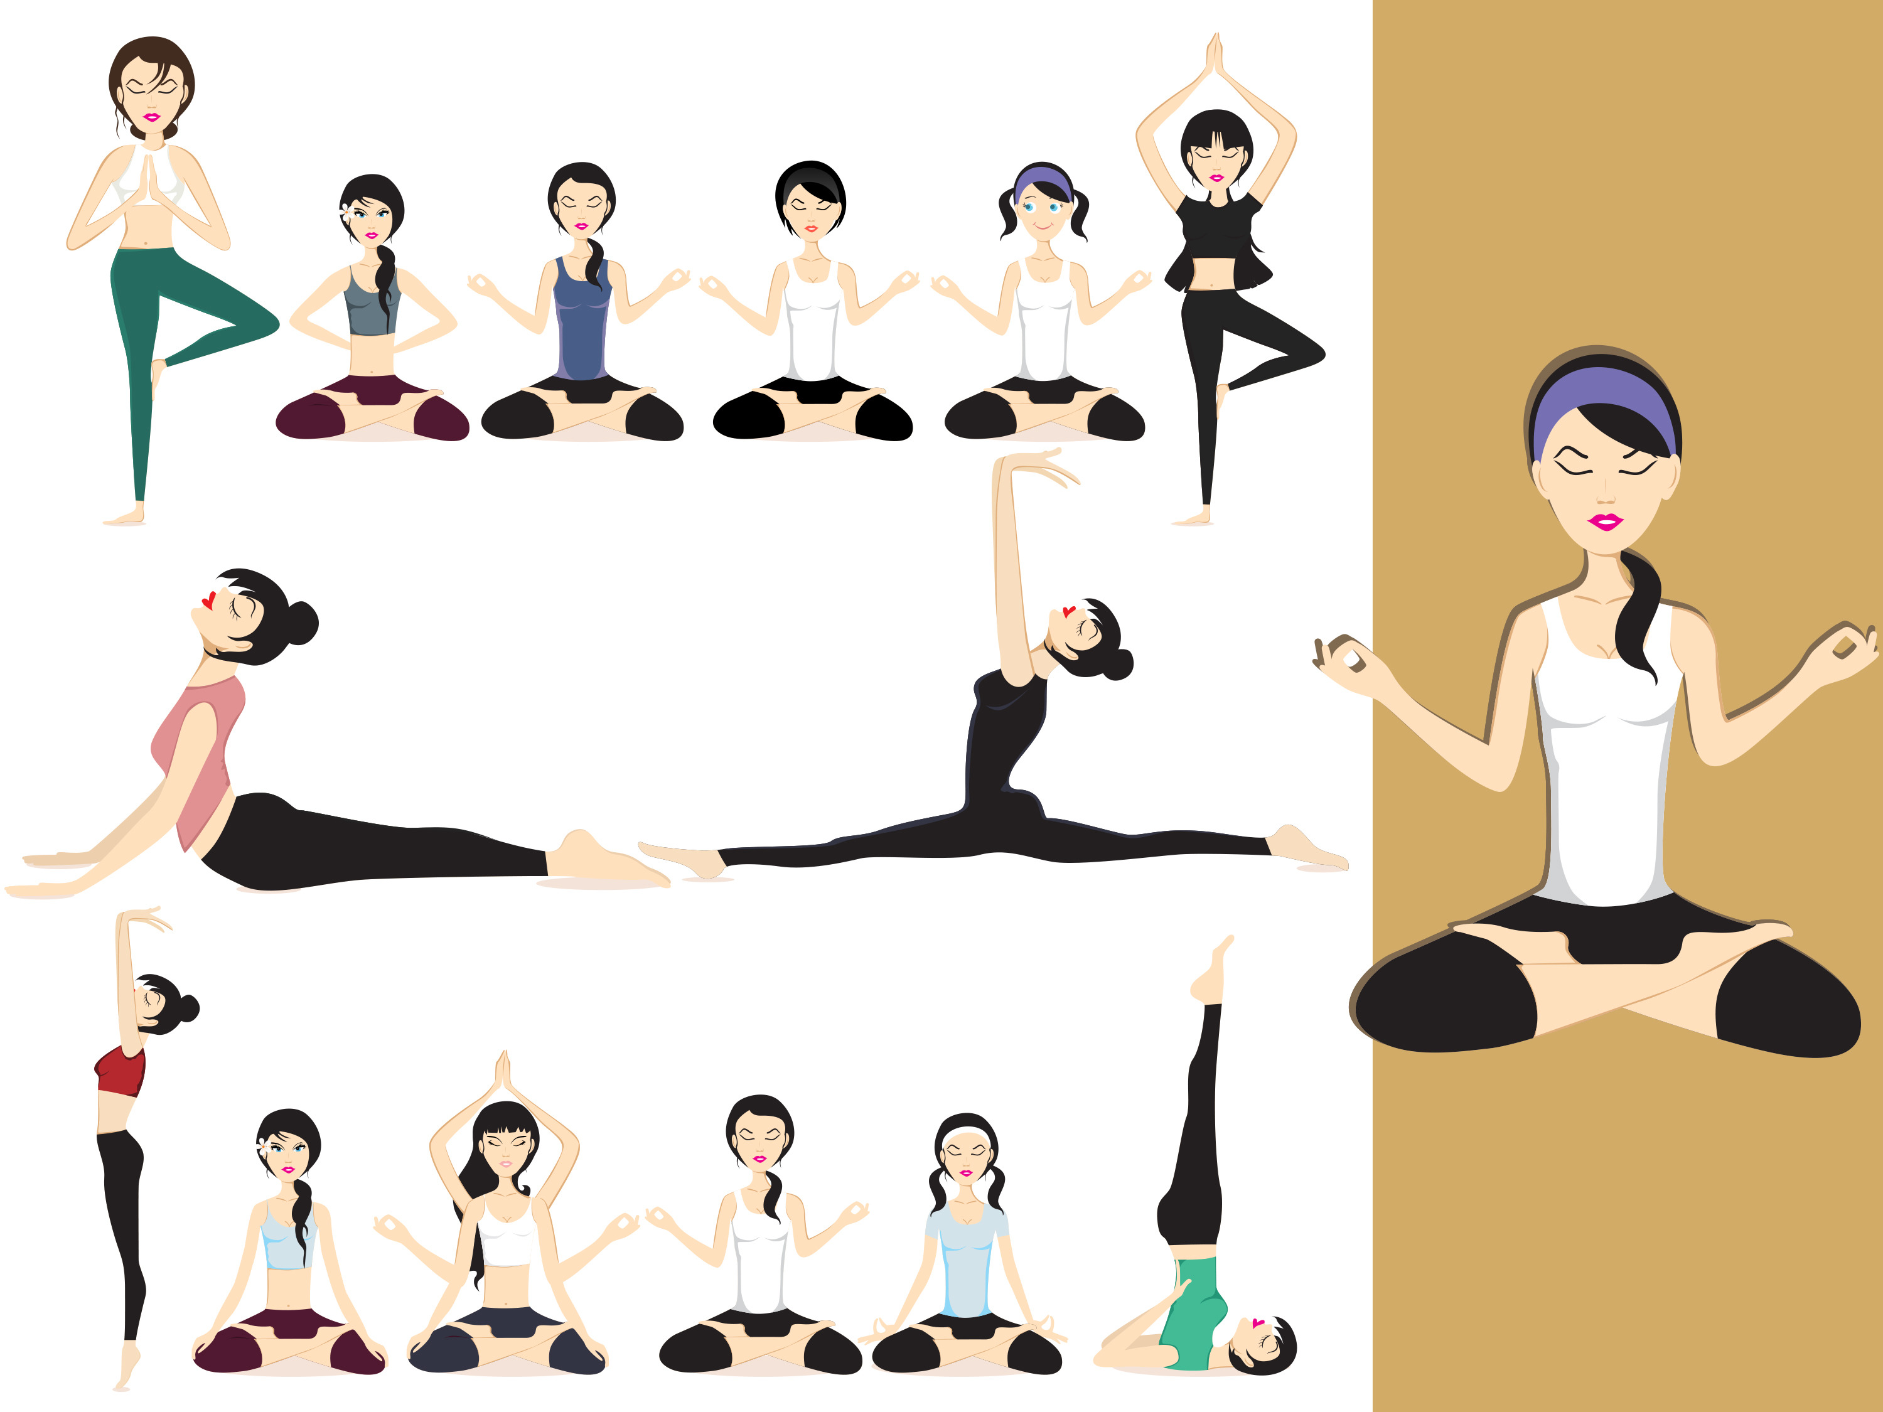
2. Achieve a long, lean sculpted body with yoga. Contrary to popular belief, yoga is not a muscle building / sculpting activity. The body is composed of 2 distinctive types of muscle fibers that have specific and individual purposes: Slow-twitch and fast-twitch fibers. Fast-twitch fibers build and sculpt the body, while slow-twitch fibers promote endurance. Working both muscle fiber types is essential to build and sculpt a strong, lean body. Yoga mainly uses slow-twitch muscle fibers, and isometric contractions that promote endurance, not muscle building. Performing yoga without incorporating strength training activity can result in joint instability caused by overstretching and a loss of those precious fast-twitch muscle fibers. You won’t benefit from any substantial caloric burn doing yoga either, and the release of mood-boosting neurochemicals is significantly smaller than strength training, which is known to release a massive amount of endorphins, faster.

3. Cross training compounds results and saves time. Beware, these types of trainings are entirely unsustainable, extremely hard on the body and have an average injury rate of 75%. Unless you are a pro athlete training for specific reasons, don’t go there!

4. Walking can also be a valuable stress relief activity and offer health benefits for the body, mind and spirit. You won’t get fit though, or prevent saggy arms and dimpled thighs. While walking could help in toning your legs somewhat, it does not sculpt, tone or have the capacity to rebuild lean muscle mass. It won’t strengthen your spine that supports your body’s posture, and you will actually lose overall muscle mass.

5. Swimming does offer general health benefits no doubt. However, you could develop an unbalanced body and acquire strong arms and shoulders, while your torso area and legs are not getting defined. Olympic swimmers swim thousands of laps weekly and complement their training with weights. You could also begin to appear pudgier, because the body stores fat in order to keep itself warm in the water. Also some studies show that swimming in cold water stimulates the appetite and creates a desire to eat more, resulting in an increase caloric intake, thus weight gain
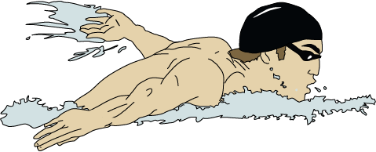
4. STRENGTH TRAINING: NEW KID ON THE BLOCK

Actually, strength training is not so new. Ancient Egyptian and Greek societies used weight training to gain strength and measure power. Weight lifting can also be traced to India in the 11th century, where people lifted stone dumbbells to help overcome the challenges of daily life.
Some of the scientifically proven benefits of strength training include:
- Boosts metabolism
- Regulates hormonal imbalances
- Builds bone density mass (prevents or reverse osteoporosis)
- Reduces risk of diabetes, heart disease, arthritis
- Improves cholesterol, blood pressure, glucose metabolism and insulin sensitivity
- Reduces the appearance of cellulite
- Fights against depression and stabilizes mood behavior
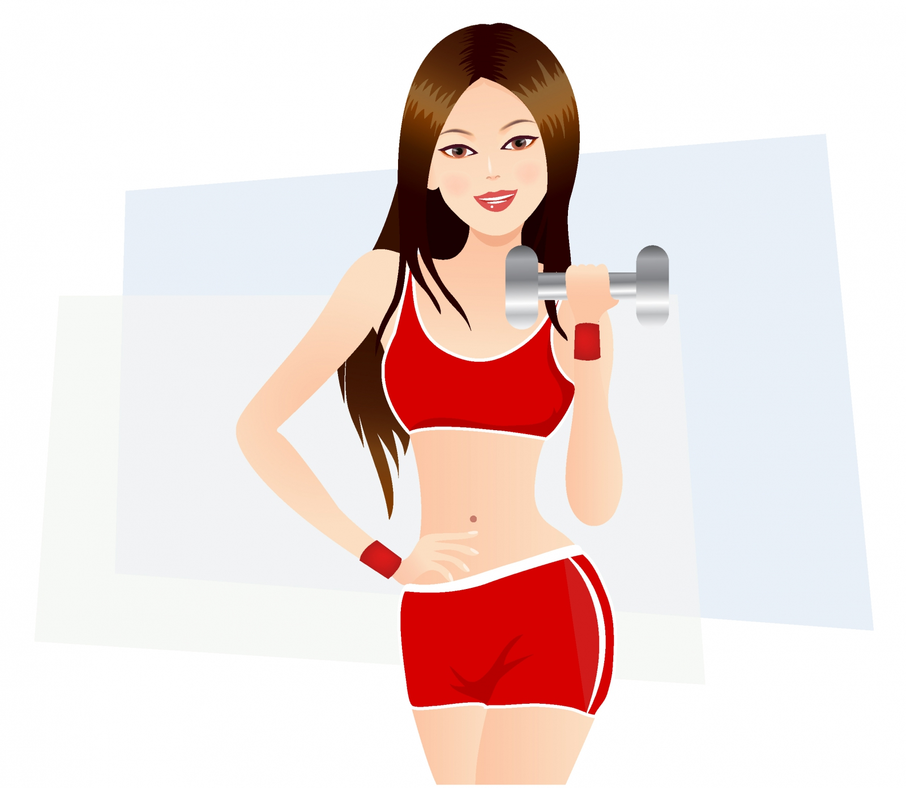
Yes, strength training has superior abilities to produce those wonderful neurochemicals that makes us feel good and have the capability to assist us in being more in control of our lives.

BUT ARE ALL STRENGTH TRAINING PROGRAMS CREATED EQUAL? NO!

Critical components are overlooked in most training systems

1. The importance of physically strengthening the nervous system through a tested and proven strength training protocol
- To stabilize mood behavior and fight against depression
- To enable the individual in recovery to make healthy decisions while under stress
- To sustain a healthy lifestyle over a long period of time
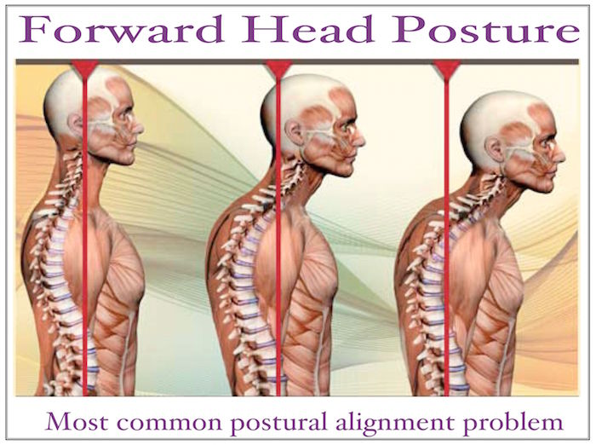
2. Correcting postural alignment
- The prevention and rehabilitation of injury, for pain management
- The proper distribution of neurotransmitters throughout the body ⁸
- To stabilize mood behavior and fight against depression

These are crucial factors that affect emotional stability, the ability to manage stress, that improve physical health and quality of life, and will dramatically influence, recovery success rate.

What needs to be understood is the information received in a therapy session is intellectual data. Once you leave the session you need to ground the body physically in order to maintain emotional and mental stability under stress and apply to tools provided by your therapist.

The body is a physical entity that reacts to the law of gravity. It is a self-healing organism and the nervous system is responsible for it’s healing.

5. STRESS

So lets just take a moment and explore the role of the nervous system in the battle for stress relief and healing physically and emotionally, in the recovery process.

Our nervous system controls the function of every cell, tissue and organ in our body and coordinates them together as to enable our body to work in perfect harmony. True health means that our body is functioning at a hundred per cent capacity, and this does not necessarily represent how we feel. A person could have cancer or heart disease and feel great, but obviously be in very poor health.

It is important to make the connection that health, mental and physical, including sobriety, is controlled by our nervous system. Therefore, in order to have true health, the nervous system must be able to control and coordinate the function of every cell, tissue and organ without interference.
The brain and spinal cord are connected to every cell an organ via our spinal nervous system. The spine, to assist them, is composed of three types of nerves.
Sensory nerves: These nerves tell our brain what is happening in our internal and external environment.
Motor nerves: These nerves controls and coordinate our muscles.
Autonomic nerves: These nerves control and coordinate our organs and glands.

To recap, in simple terms, if the electrical box in your house is too small, you will probably find the lights flickering on and off when you run too many appliances at the same time. You may even blow a fuse because the circuit is on overload. In order to accommodate the load, you will need to upgrade or even completely rewire your electrical system.

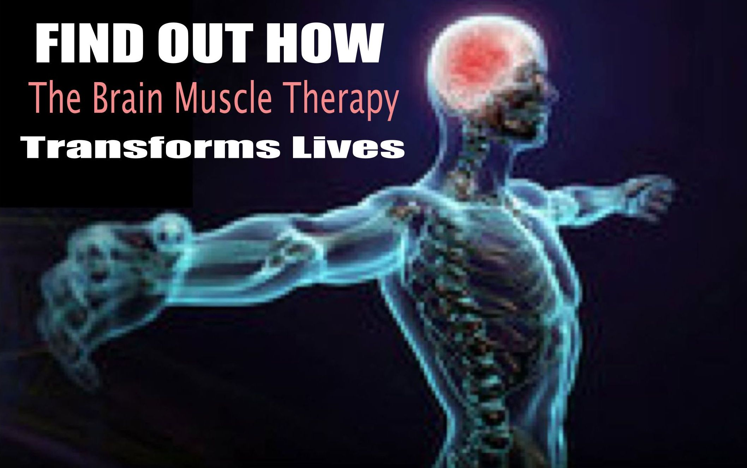

It is the same with the nervous system; if put on overload, it will not be able to handle the stress in your life. The nervous system is the control and communication system of the body. Its job is to send and receive messages. The nervous system controls all our thoughts and movements, via the spinal column.

That is why we must learn to protect and strengthen our nervous system and concern ourselves with proper postural alignment in order to clear the neuromuscular pathways to the brain.

There are multiple ways to calm the nervous system, for example walking in nature, hugging a tree, breathing, meditating, which are helpful but only address the issue partially.

The Body Design Formula created by Dr. Fitness USA offers a revolutionary protocol. The body undergoes a targeted series of specific sequences of strength training exercises that impact the nervous system with a tremendous amount of physical strength and releases a massive dosage of endorphins throughout the body very rapidly. This process links the brain-muscle connection, instantly quiets the mind and creates an immediate feeling of calm, empowerment and accomplishment.

6. PAIN

At the same time, this protocol addresses postural alignment and muscular imbalances, which will address most common physical pain, such as neck, back pain or shoulder pain for example. The side effects are a beautifully sculpted balanced body and a physique you could only dream of having, beyond your wildest imagination. Body Design Formula by Dr. Fitness USA is quite unique in its applications and outcomes.

Now it is important to mention that not every exercise modality is created equal and produce the results above mentioned. As a matter of fact, some could be seriously counterproductive to the recovery process, a healthy body, mind and spirit, and even purely and simply detrimental; it is unfortunate to witness well-intentioned fitness aficionados become injured as a result of following plans that put unnecessary stress on the nervous system, joints, tendons and ligaments, Too many exercise programs do not provide a healthy and solid foundation as outlined here. I will illustrate my point with a metaphor.
THE THREE LITTLE PIGS:
We all know the story of the three little pigs, right? The first pig built his house with straw, the second used sticks, the third one was smarter and even though it required more patience and more work, he built his house with bricks. When the big bad wolf came, and huffed and puffed, he blew down both houses made of straw and sticks, only the house made of bricks held up.

And so it is with the human body. Sadly, most people address their fitness regimen without a plan and without understanding the crucial importance of building a strong foundation, which means addressing issues such as restoring proper postural alignment and strengthening the nervous system as mentioned above, as well as correcting muscle and structural imbalances, among other factors like taking into consideration lifestyle and environment.
And so, as depicted in the three little pigs’ tale, when the unexpected challenges of life happen, inevitably the body gives out, unless you have prepared yourself ahead of time.
7. RELATHIONSHIP
Now that we understand the different types of exercise, the results to be expected from each and the role of a solid structural foundation for physical, mental and emotional health, you might ask:” How does this have anything to do with relationships and recovery and / or relapses.

Relapse in recovery is common, it happens in stages, often beginning with unresolved issues that lead to uncontrollable negative emotions such as anger, anxiety, fear, and resentments. Temptations often emerge out of nowhere; unforeseen pressures, psychological and circumstantial, may build progressively and then unexpectedly combine to drive the person over the edge. Having lost tremendous functional strength through the addictive unhealthy lifestyle, he/she is now unable to think things through and make healthy decisions.
In the next 3-part series, I will address three of the most common triggers to relapse, which are relationship, stress and emotional / physical pain. In this issue, we’ll begin with relationships.

Relationships: Resentment is considered one main offender when it comes to relapse. A foundational concept to acknowledge before going on, is that all relationships begin with the relationship with ourselves and our own ability to love and forgive ourselves first, then forgive others and let go of resentments and regrets. Since the addict’s emotional growth was stunted when the active addiction started, they face many challenges for healthy relationships. Some factors may include fear of rejection, fear of intimacy, poor self-esteem. Constantly caught between thoughts and feelings, he/she is vulnerable to relapse, if rumination continues without taking any actions.

The most commonly adopted methods to address this phenomenon in recovery are based on intellectual knowledge through the medium of workshops, support groups, therapy etc…. Those methods are valuable, however much emphasis is placed on the social, psychological and emotional causes of the disease via intellectual data, while little attention is placed on grounding the information into the physical body, which houses the information. When it is all said and done, at the end of the day, the fact remains that addicts and alcoholics, are by nature uncomfortable in their own skin; always seeking to escape that feeling of being present and lacking the desire and ability to be grounded. This results in the inability to set healthy boundaries, which is a key factor in relapse.

Every action creates a reaction and every motion creates an emotion.

Strength training is a specific action step that can be taken immediately to provide instant functional strength increase and begin to change one’s habits to a positive mind-set. It provides fast and measurable results, and rebuilds the alcoholic brain by increasing neurogenesis. It offers an avenue to blow off steam so to speak and quiets the mind. It also allows a safe place to let go of negativity, and distance yourself from undesired situations. When done properly, it also presents off the chart health opportunities for men and women.
When you start feeling better in your own skin, you will automatically begin to make new relationships that support your newfound self-esteem and lifestyle. Men and women who have grown up believing that they are victims of everything from their mothers to the foods and the drinks they consume begin to experience a new sense of self-confidence and self-respect, feeling powerful, competent and capable of taking charge of their bodies and their lives.
7. CONCLUSION
The three foundational pillars that differentiate the Body Design Formula Strength Training System created by Dr. Fitness USA from other fitness modalities, have guaranteed its success for over four decades, and establish it as the only logical choice for inner and outer fitness are:
- Symmetry: postural alignment and correcting muscular imbalances that lead to injuries
- Strength: physical and emotional stability by strengthening the body and the nervous system
- Sustainability: Long term vision for a balanced lifestyle in body mind and spirit
THE BODY DESIGN FORMULA STRENGTH TRAINING SYSTEM OFFERS A REVOLUTIONARY NEW APPROACH TO RECOVERY FROM ADDICTION.

Dr. Fitness USA works with individuals as well as with treatment centers and recovery facilities.
- Setting up workout facilities in recovery centers
- Designing strength training systems for in or outpatients clients
- Individual and customized programs for executives and celebrities
- Lectures and speaking engagements
- Community outreach educational seminars and workshops
CALL TO SHCEDULE A FREE FOLLOW-UP, 15 MINUTES CONSULTATION TO DISCUSS YOUR NEEDS.
424.245.6560

CONNECT WITH US ON THE SOCIAL NETWORKS /@# DrFitnessUSA
Visit DrFitnessUSA.com and subscribe to our newsletter
Visit YouTube.com/DrFitnessUSA channel, subscribe, like, comment, share
Write doc@drfitnessusa.com and schedule a 15 minutes free phone consultation
CALL 424.245.6560

Stay tuned for our next book “Stronger than Medicine” coming up December 2015

ABOUT THE AUTHOR

BATISTA GREMAUD is a Published Author, Empowerment Speaker, Entertainer and Co-founder of Body Design Formula and the International Institute of Body Design.
BATISTA GREMAUD is a Body Design Formula 7th degree Master teacher in the Dr. Fitness USA protocol. Also certified in personal training, Batista's expertise in strength training includes structural realignment of the spine, getting rid of back pain without surgery, injury prevention and post rehabilitation of injuries. Batista has been teaching the Body Design FormulaTM protocol as an independent trainer at Gold’s Gym, Venice for several years.
Certified as a practitioner in 5 healing arts modalities, Batista understands the intricate role the Body Design FormulaTM protocol and Dr. Fitness USA unique fitness philosophy of quieting the mind and strengthening the nervous system plays in the field of addiction recovery and stress management, for the true integration of body, mind and spirit towards the complete consciousness shift within an individual and the evolution of the planet. She regularly appears as a celebrity guest expert on radio shows, on the topic of fitness and consciousness.
Batista Gremaud is the author of “ Feminine Body Design” “How to lose weight and look good with strength training” “Extreme muscle makeover” and “Poster 4 Power” available on Amazon. She regularly writes for addiction and recovery magazines and online health platforms and is in the process of writing her 4th book: “Stronger than Medicine”, scheduled to be released late 2015.

ABOUT DR. FITNESS USA

STEPHEN HERCY aka Dr. Fitness USA is an International Body Designer, owner and FOUNDER OF THE INTERNATIONAL INSTITUTE of BODY DESIGN.
Holds the prestigious title Professeur De Culture Physique Weider and is certified by the IFBB International Federation of Bodybuilding.
Stephen Hercy has assisted women to greater health for over forty-five years and is the first person worldwide to have created strength-training programs specifically for women with endometriosis.
Stephen Hercy is a published author of several books, and a recognized professional empowerment speaker as a pioneer for his successful work with pain management and postural realignment, which affects mood behavior and productivity, and is running the most reliable body sculpting program globally. He regularly appears as a celebrity guest speaker on radio shows, including syndicated show “People of Distinction” with Al Cole and “Amazing women of Power.”
Stephen Hercy is the leading authority in bringing his revolutionary strength training systems to the addiction and recovery community as a new tool for mood behavior stabilization and stress management. Dr. Fitness USA has worked with all types of people from celebrities such as Linda Gray, Sally Fields, Simon Cranes, and Billy West as well as with MD’s, chiropractors, alternative health professionals, as well as students. Young and older people of all walks of life, travel worldwide to seek his unique services.
20% to 50% STRONGER IN 20 MINUTES
The Strength Will Stay With You

If your mind can conceive it, and your heart believe it, then Dr. Fitness USA can help you achieve it!

WELCOME TO THE NEW PARADIGM IN FITNESS CONSCIOUSNESS

NEW!
FEMININE BODY DESIGN
Empowering Fitness For Pain Free Life
Read It Now

Written by Batista Gremaud
7th degree Body Design Formula™ Master Teacher
Empowerment Speaker
International Institute of Body Design co-founder
Author of “How to lose weight and look good with strength training” and
“Extreme Muscle Makeover”
Coming soon to a bookstore near you
“Stronger than Medicine”
Body Design Formula © - 2015– All rights reserved
www.DrFitnessUSA.com

REFERENCES

- Resistance Exercise: Health Benefits and Medical applications – Medical Fitness Association 2014 – Wayne Westcott: http://c.ymcdn.com/sites/www.medicalfitness.org/resource/resmgr/2014_AIC_Presentations_/Wayne_Westcott_presentation.pdf
- New findings imply Exercise in adolescence may help prevent drug abuse. Sophie Bushwick https://www.bnl.gov/newsroom/news.php?a=11159
- http://www.drugabuse.gov/news-events/nida-notes/2011/03/physical-activity-may-prevent-substance-abuse
- Dr. Brad Roy, Summit Medical Fitness Center, Kallspell (Wall Street Journal Sept, 15th 2015)
- MK Mc Gover Effects of exercise on the brain / Biology 202, Spring 2005
Second Web Papers http://serendip.brynmawr.edu/bb/neuro/neuro05/web2/mmcgovern.html
- NIDA Director Nora D. Volkow - http://www.drugabuse.gov/news-events/nida-notes/2011/03/physical-activity-may-prevent-substance-abuse
- Dopamine, serotonin and impulsivity Neuroscience, Volume 215, Issue null, Pages 42-58 J.W. Dalley, J.P. Roiser
- Dr. Kenneth Hansraj, chief of spine surgery at New York Spine Surgery and Rehabilitation Medicine

